**Section: ___ Group Number: _______ Score: ______/20**

**Names of Group Members PRESENT: ____________________________________**

Credit is only given for group work to those present onall days L&LA is worked in class and who are also present theday it is turned in.

**____________________________________**

**____________________________________**

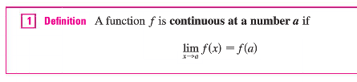 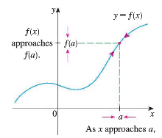

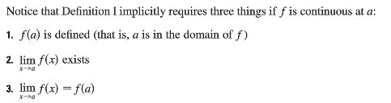

**Graphically:**

Basic idea: A function is continuous if you can draw it without picking up your pencil.

These are examples of continuous functions:

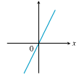 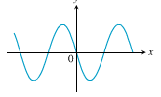 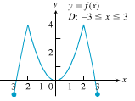 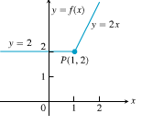

Discontinuities fall into certain classes.

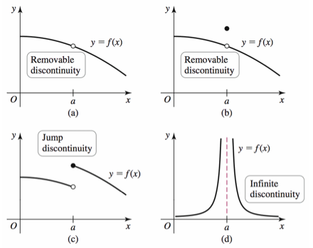 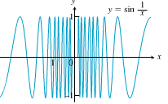

Oscillating discontinuity

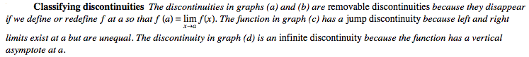

Consider video example 2 page 119 in electronic text.

1. Determine the points at which the following functions have discontinuities. For each point(s), classify the discontinuity and state the conditions of the continuity checklist that are violated.

|  |  |  |  |
| --- | --- | --- | --- |
| Picture 4 |  | ::::Desktop:Screen shot 2010-09-30 at 10.25.19 AM.png |  |
| ::::Desktop:Screen shot 2010-09-30 at 10.44.25 AM.png |  | **Picture 5** |  |
| **step function**  . |  |  |  |
| ::::Desktop:Screen shot 2010-09-30 at 10.47.34 AM.png |  | ::::Desktop:Screen shot 2010-09-30 at 10.48.38 AM.png |  |
|  |  |  |  |
|  |  |  |  |
| ::::Desktop:Screen shot 2010-09-30 at 10.50.06 AM.png |  |  |  |
|  |  |  |  |
| Picture 4 |  | Picture 1 |  |
| ::::Desktop:for 2.6 lesson:#10.png |  | ::::Desktop:for 2.6 lesson:#12.png |  |

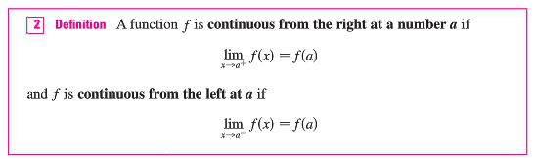

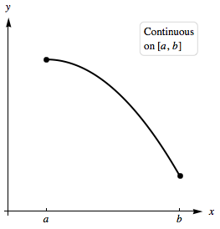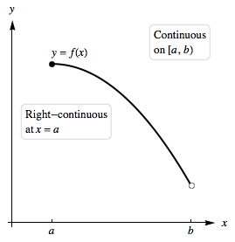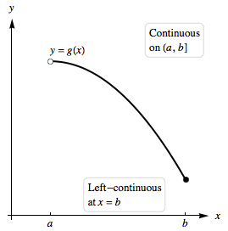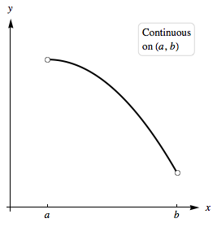

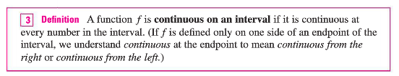

2. Determine the intervals of continuity for the last graphs in #1 (copied here).

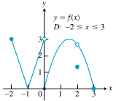 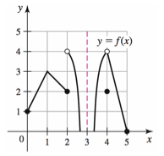

**Algebraically:**

We need to be precise in our presentation of why a function is not continuous at a point. We will use the continuity definition breakdown.



3. Determine whether the following functions are continuous at . Use the continuity checklist to justify your answer.

a.  at 

b.  at 

c. at 

d. **Absolute Value** 

e. 

**::::Desktop:for 2.6 lesson:direct sub.png**The text has a good discussion on pages 121-125 on which types of functions are continuous (or continuous except at a few important points). I would suggest that you read these pages in detail.

In summary

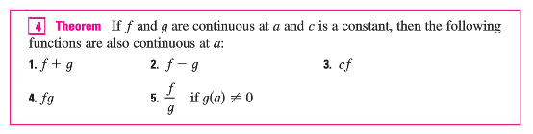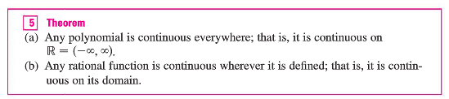

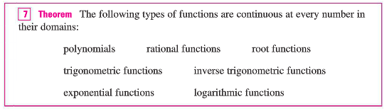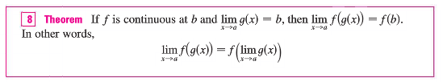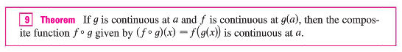

4. MacHD:Users:dsimms:Desktop:Screen Shot 2014-09-25 at 9.33.56 PM.png

a. MacHD:Users:dsimms:Desktop:Screen Shot 2014-09-25 at 9.34.03 PM.png b. MacHD:Users:dsimms:Desktop:Screen Shot 2014-09-25 at 9.37.31 PM.png

5. (2.5:#40) Show that *f* is continuous on 



6. Determine the intervals on which the following functions are continuous. Use proper brackets/parentheses to specify left or right continuity or not.

a.  b. 

c.  d. 

7. a. Sketch the graph of a function that is not continuous at 1, but it is defined at 1.

b. Sketch the graph of a function that is not continuous at 1, but has a limit at 1.

8. Determine the value of the constant  for which the function  is continuous at .

9. Determine the value of the constant  for which the function is continuous at .

10.  has a removable discontinuity. Redefine the function so as to remove the discontinuity. Use limit(s) to support your answer.

11. (2.5:#47b) has a removable discontinuity at . Redefine the function so as to remove the discontinuity. Use limit(s) to support your answer.

12. Let 

a. Show that the function if not continuous at .

b. Is the function continuous from the left or right at ?

13. What types of discontinuities do the following functions have? Support your answers with limits.

a. 

b. 

c. 

e. Conclusions:

A function has a removable discontinuity when

The discontinuity can be removed with

A function has an infinite discontinuity when

A function has a jump discontinuity when

**INTERMEDIATE VALUE THEOREM**

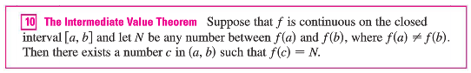

|  |  |
| --- | --- |
| **MacHD:Users:dsimms:Desktop:Screen Shot 2014-09-25 at 6.32.14 PM.png** | **It is important that the function be continuous.**  **::::Desktop:for 2.6 lesson:2nd good IF.png** |
| The IVT lets you show that a function has roots (solutions, zeros)  • Find an “a” value that gives a negative output  • Find a “b” value that gives a positive output  • If the function is continuous it has to have passed through the output of zero. | EXAMPLE:  Show that  has a solution. |

14. Use the IVT to show that the equation  on the interval .

15. Use the IVT to show that the equation  on the interval .

16.

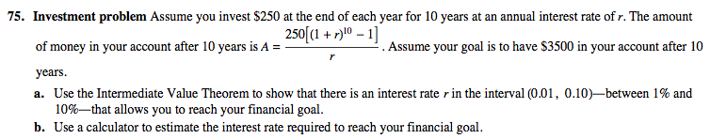

HW 2.5:# 3, 6, 10a, 10e, 14, 17, 21, 24, 27, 30, 39, 41, 46, 53, 55